**Configuration**

Created new Definition ID ‘THA01’ for UK Payment Request Approval Process

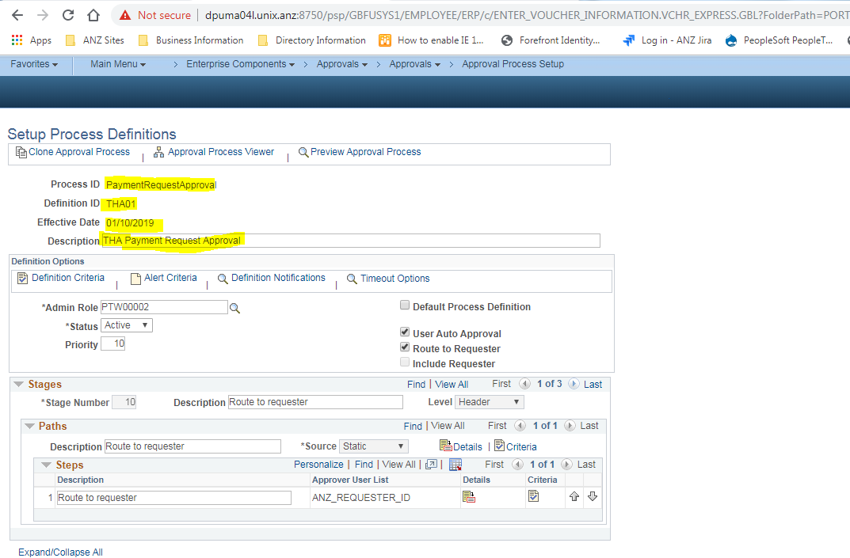

Defined Business Unit ‘00160’ criteria for UK so that only this Definition ID will be triggered for Payment Request Approval

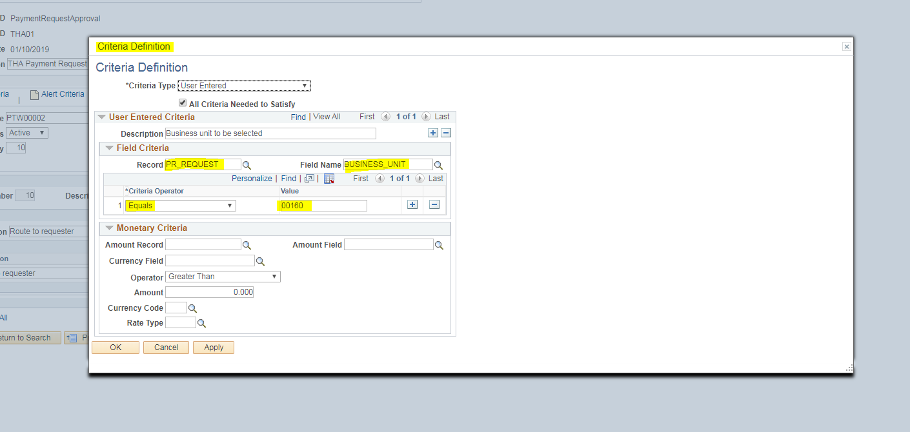

Stage 1: Requestor Approval

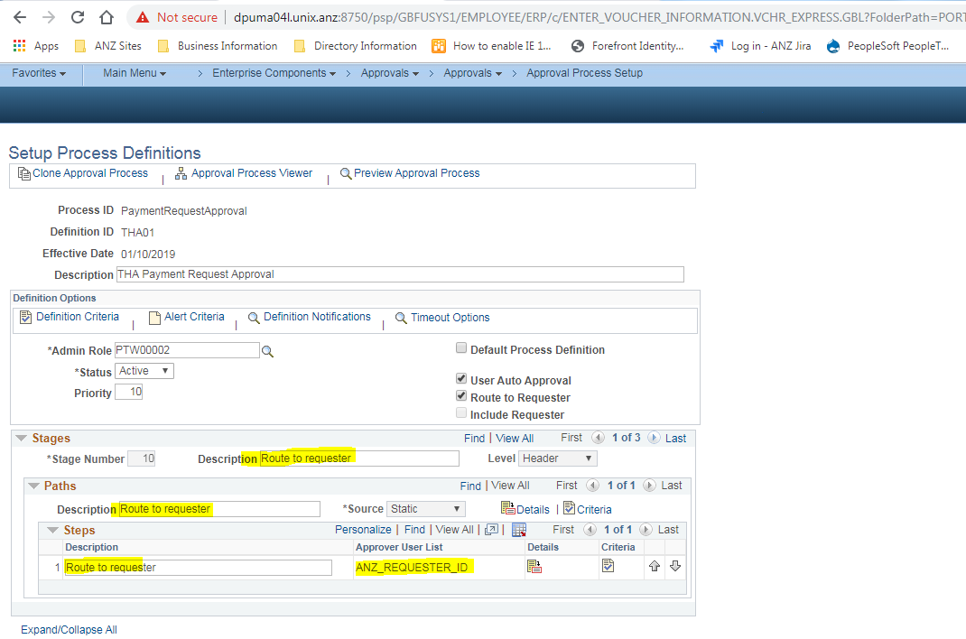

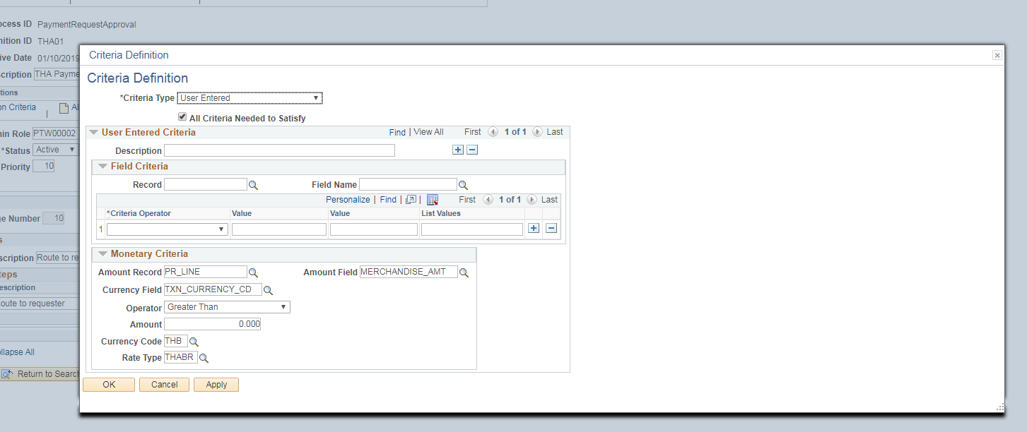

Stage 2: Line Manager

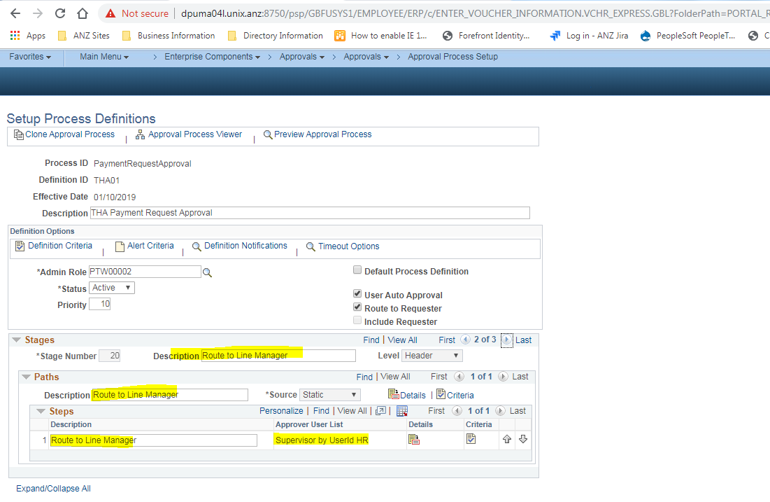



Stage 3: DFA – Amount Approval

